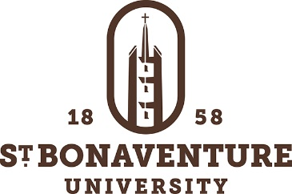

NCAA Athletics Licensed Mental Health Counselor

Job Purpose

This full-time, 10-month position will provide individual and group counseling sessions; educational seminars; and consultation and referral services to the NCAA Athletics Department of St. Bonaventure University. Emphasis will be on ameliorating mental health conditions and related issues typically experienced by student-athletes engaged in competitive sports at the Division I University level. The candidate will also share on-call duty with the other campus counselors.

Minimum Qualifications:
Education: Master’s Degree in Counseling Psychology, Counselor Education, Social Work, or related field required. Must possess an active New York State license or limited permit in mental health counseling, clinical social work, or psychology. Prior counseling experience with college student athletes and/or experience dealing with crisis issues required. Skill in providing seminar/workshop-type education sessions preferred.

Experience: Strong preference in this position will be given to candidates who have prior experience working with student athletes. In order to be considered, all applicants must have at least 1 year of experience working in a college or clinical mental health role in an agency setting.

Knowledge, Skills, and Abilities
  - Master’s level knowledge base of counseling theories, skills, and industry trends.
  - Knowledge and understanding of the special considerations and challenges faced by student athletes
  - Trained in and current CPR certification
  - Knowledge and clear understanding of HIPAA and FERPA guidelines
  - Skilled in the use of electronic medical record systems.
  - Ability to speak to groups of students including and especially athletic teams on mental health topics which directly or indirectly impact performance

Characteristic Duties and Responsibilities
- Conduct individual mental health counseling sessions and, when needed, group sessions related to mental health with groups of athletes.
- Provide educational sessions for teams on topics relating to mental health self-care.
- As scheduled, will respond to on-call crisis evaluations as needed. On-call will include scheduled nights, weekends, and possibly holidays. Occasional travel on and off campus.
- To assist with campus outreach events as organized by the NCAA Athletics Department, Counseling Center, and Health Services.

Please send letter of application, resume and contact information for three references to hr@sbu.edu
St. Bonaventure University is an Affirmative Action/Equal Opportunity educational institution. It is guided by the principle that equal opportunity means more than equal employment opportunity, and that access to facilities and services shall be available to all people regardless of their race, color, religion, sex, national origin, age, veteran status, disability, marital status, sexual orientation, or gender identity/expression. This principle is applicable to every member of the St. Bonaventure community, both students and employed personnel at every level, and to all facilities and services.
In light of its commitment to create and maintain a safe learning and working environment, employment with St. Bonaventure University requires successful completion of a background screening.

