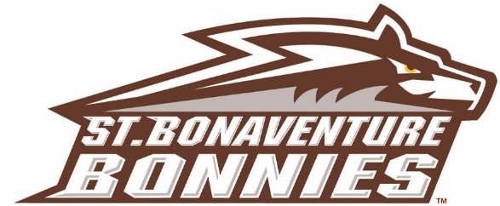

Assistant Athletic Director for Sports Medicine/Head Athletic Trainer

St. Bonaventure University, an NCAA Division I institution and a member of the Atlantic 10 Conference, is accepting applications for the position of Assistant Athletic Director for Sports Medicine/Head Athletic Trainer. This is a full-time, 12-month exempt position which reports to the Sr. Associate Athletic Director for Compliance

QUALIFICATIONS:
- Minimum of 5 years full-time athletic training experience in a collegiate setting. Previous experience as Director of Sports Medicine preferred.
- Master’s Degree
- Must be BOC certified and possess or eligible for NY state athletic training licensure. NPI Number Required.

DUTIES & RESPONSIBLITIES:
  - Administers and oversees the care, prevention, evaluation, treatment and rehabilitation of injuries to all student-athletes.
  - Manages and supervises sports medicine staff.
  - Acts as the Athletic Health Care Administrator per NCAA guidelines
  - Organizes and maintains all medical records in accordance with federal and state regulations.
  - Develops and maintains emergency action plans for all permanent and temporary practice and competition venues in accordance with university risk management guidelines and state regulations.
  - Develops and maintains all service contract with medical consultants.
  - Maintains student-athlete insurance information.
  - Maintains good communication with the insurance providers and manages all paperwork required for claims.
  - Develops and manages the Athletic Training Facility, budgets and policies to maintain optimal health, safety and welfare of all constituents.
  - Plans and coordinates physical examinations and screenings.
  - Communicate with physicians and coaching staff regarding the injury status of athletes.
  - Makes appropriate physician’s referrals and appointments.
  - Supervises the organization and administration of drug testing per NCAA and department policy.
  - Responsible for maintaining and coordination service for all modalities and equipment utilized with the athletic training facility.

Employment is conditional on a successful background check. St. Bonaventure University is an E-Verify institution and successful candidate must be eligible to work in the United States.

Desired start date is January 1, 2021. Cover letter, accompanied by a resume and the names/contact information of at least three references should be sent to:
Ryan Clingan
Sr. Associate Athletic Director
St. Bonaventure University
rclingan@sbu.edu

St. Bonaventure University is an Affirmative Action/Equal Opportunity educational institution. It is guided by the principle that equal opportunity means more than equal employment opportunity, and that access to facilities and services shall be available to all people regardless of their race, color, religion, sex, national origin, age, veteran status, disability, marital status, sexual orientation, or gender identity/expression. This principle is applicable to every member of the St. Bonaventure community, both students and employed personnel at every level, and to all facilities and services.

