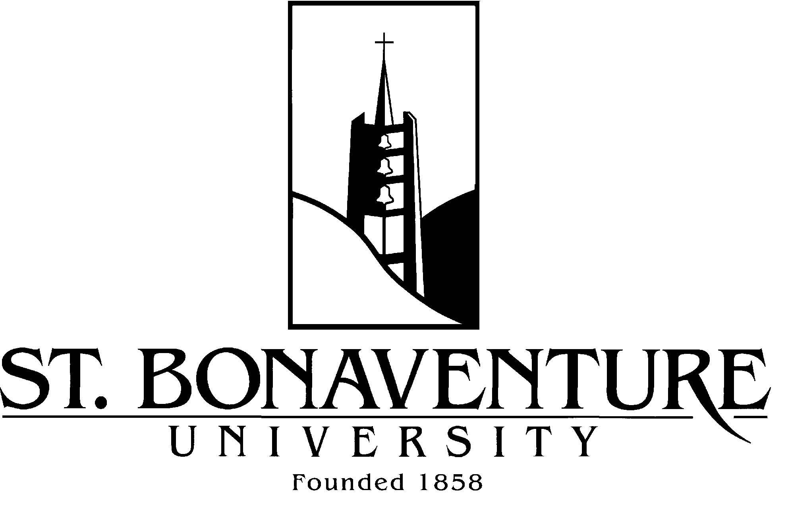

**MIDDLE STATES LIAISON SELF STUDY PRE-VISIT**

Dr. Ellie Fogarty, Vice President

Liaison Officer, St. Bonaventure University

February 21, 2013

**ITINERARY**

9 a.m.-9:30 a.m. Meeting with Sr. Margaret Carney, OSF, President   
(President’s Office)

9:45 a.m.-10:30 a.m. Open Meeting with faculty, administrators and students   
(Doyle Dining Room)

10:45 a.m.-12:15 p.m. Self Study Steering Committee Meeting and Members of APEC   
(Robert R. Jones Trustees’ Room)

12:30 p.m.-1:15 p.m. Lunch with Members of the Board of Trustees   
(President’s Dining Room)

1:30 p.m.- 2 p.m. Meeting with the 4 members of the Permanent Accreditation Committee (156 Plassmann Hall)